**Project Details**

|  |  |
| --- | --- |
| Project number | *19* |
| Project title | *Mega Store Corporation* |
| Corresponding TA\LA | *Dina Abbas* |
| Deliverable | *4* |

**Team Details**

|  |  |  |
| --- | --- | --- |
| **Student ID** | **Student name** | **Lab Group** |
| 20200629 | يارا محمد سعد محمد | S5 |
| 20200165 | حنين محمد عويس | S7 |
| 20201102 | شيرين شوقى حسن أحمد | S5 |
| 20201183 | ميار محمد حامد عبدالمجيد | S8 |
| 20200595 | ندين بدر الدين عبد العاطى | S8 |
| 20200387 | كاريمان أيمن عبداللطيف | S8 |
| 20200732 | ياسمين سامى عبد القوى | S8 |

**Phase 4: Use case Realization**

**Deliver a complete electronic report to deliver the following requirements using CASE/modeling tool(s):**

1. Select **TWO** simple use cases using the provided Use case diagram (that have been developed during the analysis phase of your project)

**Note:**

* **Choose 2 simple use cases from use case diagram**
* **For each use case:**
  + **Draw a partial class diagram by following CRC rules. Show steps for CRC cards.**
  + **Draw communication diagram then create a partial class diagram from it.**

**[Partial means that you will only put classes involved in the chose use cases.]**

1. Generate and draw a **partial class diagram** using **CRC cards** (**show steps**).

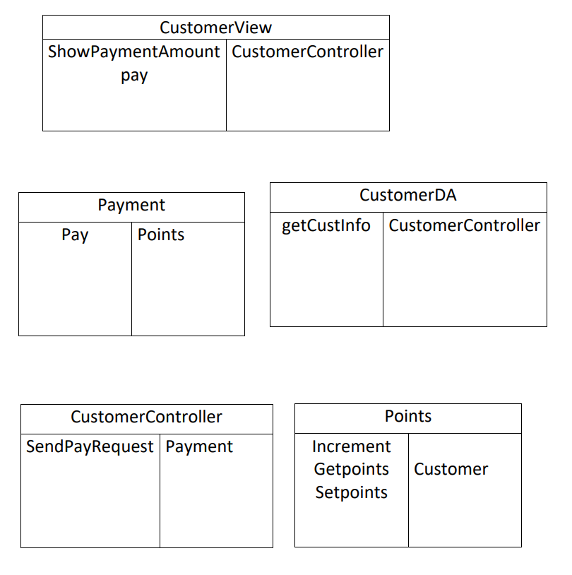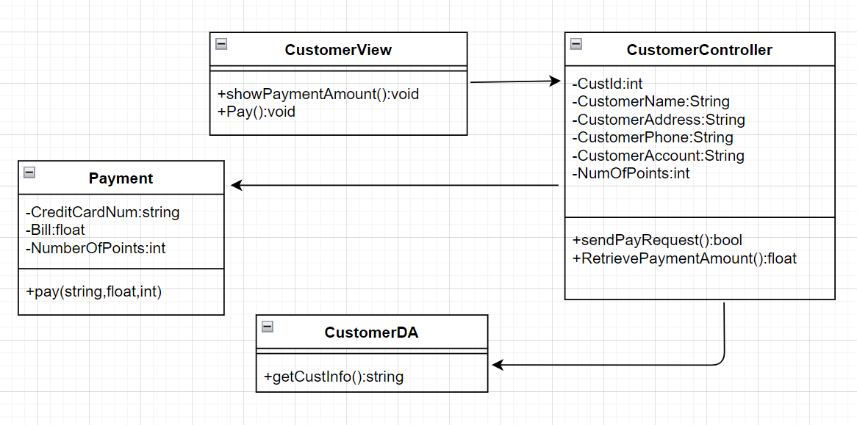

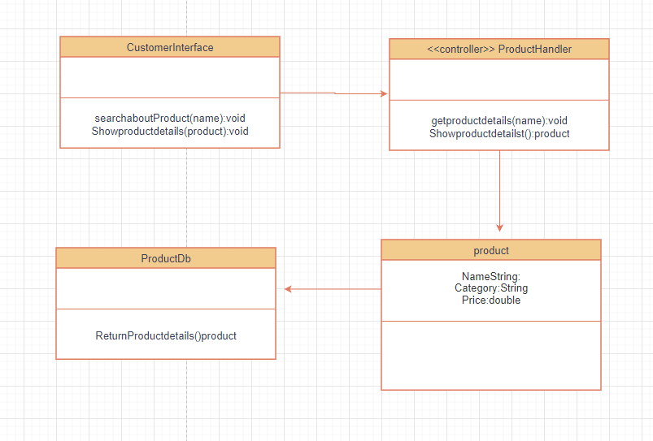

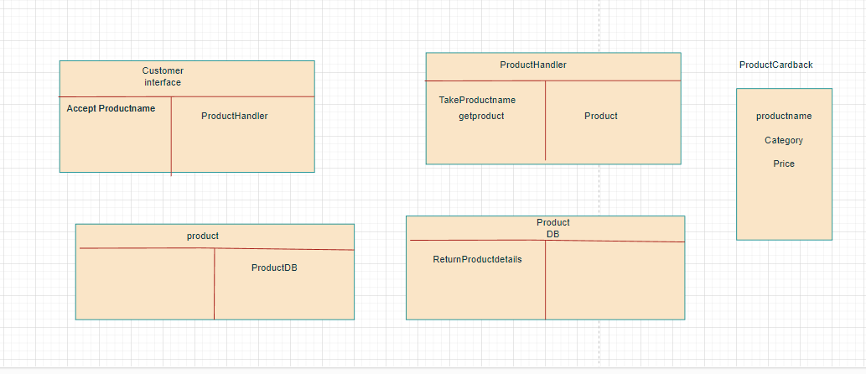

1. Generate and draw a **partial class diagram** using **communication diagram** (**show steps**).

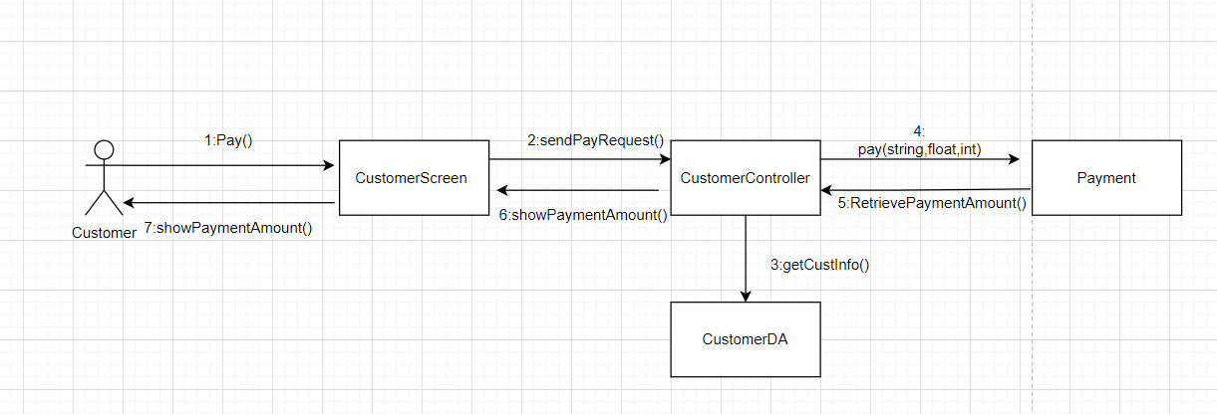



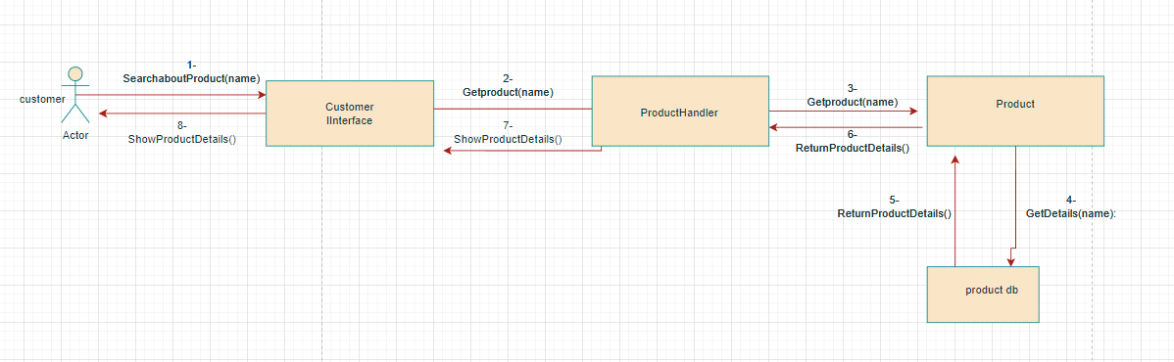

1. Select two complex use cases:

* Generate and draw a **partial class diagram** using **multi-layer sequence diagram** (**show steps**).

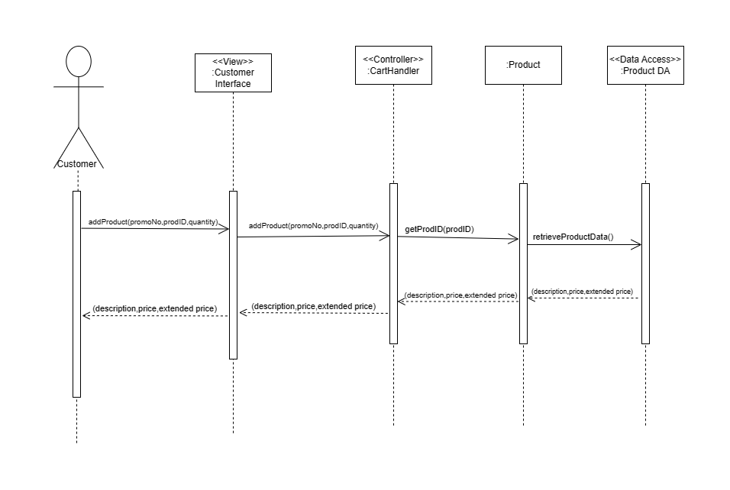

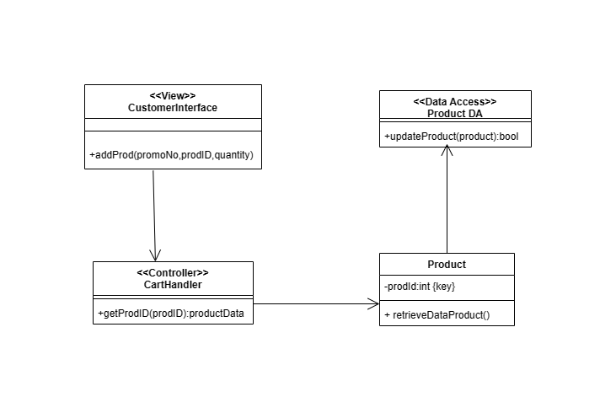

**Note:**

**For 2 complex use cases, draw your multi-layer sequence diagrams and then create your partial class diagram.**

1. Generate and draw **final-cut class diagram** output from 1.a, 1.b, and 2 [**Fully-defined attributes and methods, navigation, multiplicity**].

**Note:**

**Draw detailed class diagram for only classes involved in the above use cases.**

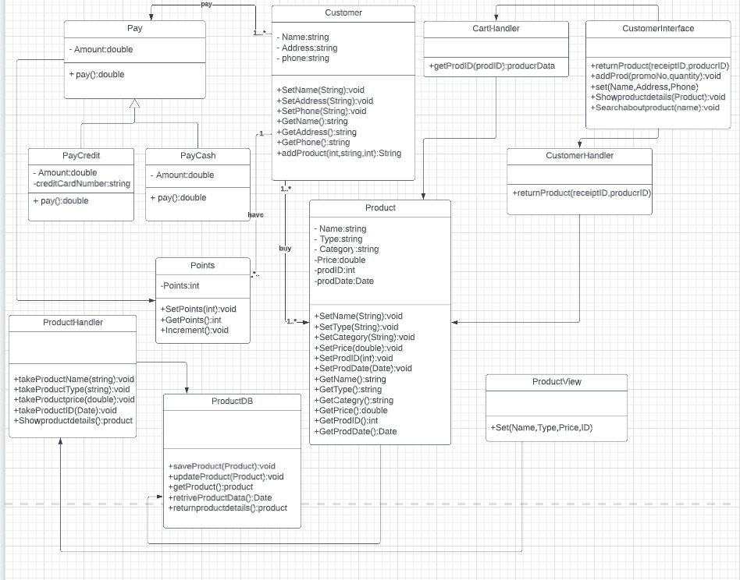

1. Generate and draw **package diagram** from the resulted detailed class diagram in 3.

**Note:**

**Draw a package diagram [View – controller – data access layers] for class diagram in point 3.**

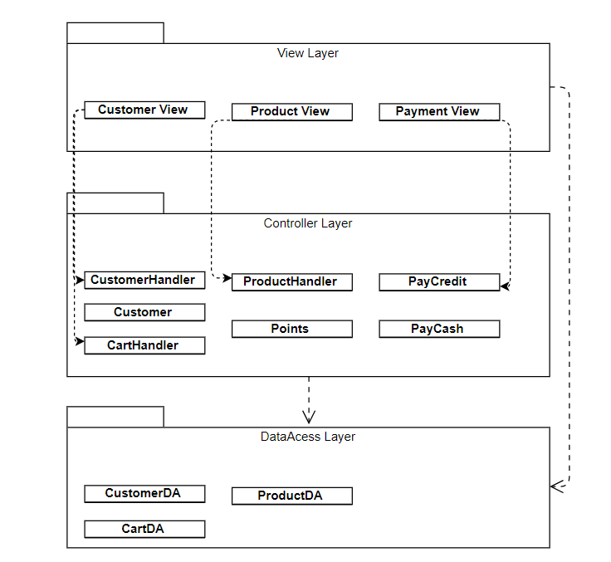

**NOTES**

* **If the file is big, you can compress it in .zip or .rar formats.**
* **Please write your team number in the title of your submission**

**Deadline: 28 / 12 /2022**